
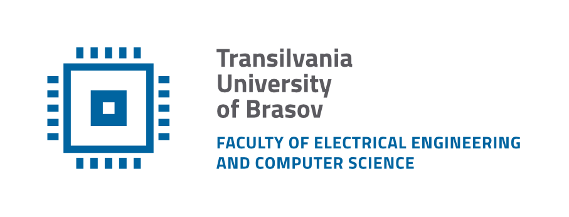
Department of Electronics and Computers
Study programme: Applied Electronics

Verification Project
Railway Management

Table of Contents
1 The digital design of the circuit 3
1.1 Block Diagram 3
1.2 Description of the general functionality of the DUT (Device Under Test) 3
1.3 DUT Interfaces 4
1.4 List of DUT Functionalities 5
1.5 Waveforms 6
2 Digital Circuit Verification 7
2.1 Verification Environment Architecture 7
2.1.1 Trains Agent 7
2.1.2 Trains Transaction 7
2.1.3 Trains Driver 8
2.1.4 Trains Monitor 8
2.1.5 Trains Coverage Collector 8
2.1.6 Trains Sequences 8
2.1.7 Semaphore Agent 9
2.1.8 Semaphore Transaction 9
2.1.9 Semaphore Monitor 9
2.1.10 Semaphore Coverage Collector 9
2.1.11 Scoreboard 9
2.1.12 Scoreboard Coverage Collector 10
2.2 Functional Coverage Elements 10
2.3 Verification Scenarios and Tests 11
2.4 Results 12

The digital design of the circuit
Block Diagram
General Functionality Description of the DUT (Device Under Test)
DUT Interfaces
List of DUT Functionalities
Schematic Diagram
Waveforms
Register Table

Block Diagram

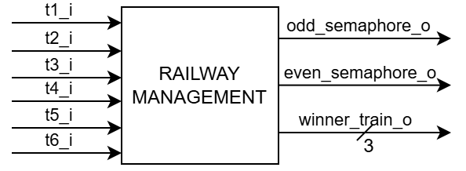
Figure 1. Block diagram of the Railway Management

Description of the general functionality of the DUT (Device Under Test)
The Device Under Test (DUT) is a railway traffic controller designed to manage the access of six tourist trains to a shared railway section located near the red panda enclosure, which represents the central attraction of the zoo. Since all trains must pass through this section during their route, a control mechanism is required to prevent collisions and ensure safe operation.
The railway network is divided into two traffic directions. Trains T1, T3 and T5 approach the shared section from the west side, while trains T2, T4 and T6 approach it from the east side. To regulate access, a semaphore is installed at each end of the railway section. The DUT controls these semaphores and determines which train is allowed to enter the shared track segment.
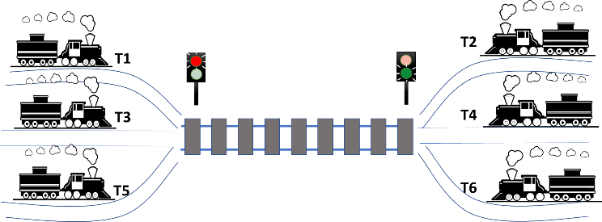
Figure 2. General idea of the railway access management controller
The controller operates according to a predefined set of priority rules. First, odd-numbered trains have higher priority than even-numbered trains. Then, trains with a smaller number have priority over trains with bigger number of the same parity. The railway section must remain unoccupied for one clock cycle between the passage of two trains belonging to different parity groups.
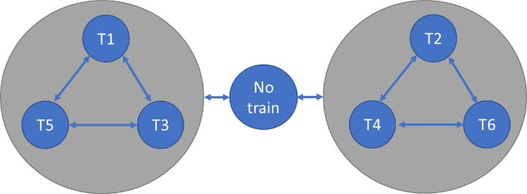
Figure 3. Finite State Machine (FSM) correlated with trains priority rules
The DUT continuously monitors the requests received from all trains and grants access to a single train at a time according to the established priority scheme. Based on the selected train, the corresponding semaphore is activated while the opposite semaphore remains blocked.

DUT Interfaces
Table 1. System signals generated in the testbench
General Signals
Signal Name | I/O | Size | Description
clk_i | I | 1 | Clock signal
reset_i | I | 1 | Asynchronous reset, active high

Table 2. Trains Interface
Trains Interface
Signal Name | I/O | Size | Description
t1_i | I | 1 | Access request from train T1
t2_i | I | 1 | Access request from train T2
t3_i | I | 1 | Access request from train T3
t4_i | I | 1 | Access request from train T4
t5_i | I | 1 | Access request from train T5
t6_i | I | 1 | Access request from train T6

Table 3. Semaphore Interface
Semaphore Interface
Signal Name | I/O | Size | Description
odd_semaphore_o | O | 1 | Semaphore control signal for odd-numbered trains
even_semaphore_o | O | 1 | Semaphore control signal for even-numbered trains
winner_train_o | O | 3 | Command for train that has access to the railway

List of DUT Functionalities
- Continuously monitors request signals received from all six trains.
- Selects a single train to access the shared railway section based on the implemented priority rules.
- Controls the two railway semaphores and grants access only to the selected train.
- Ensures that the railway section remains unused for one clock cycle when switching between odd and even train groups.
- Prevents the same train from being granted access during two consecutive arbitration cycles.

Waveforms
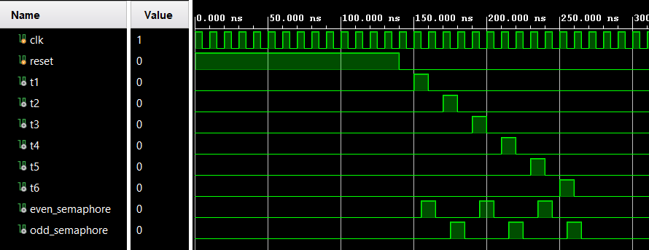
Figure 4. Waveforms from DUT for single train requests

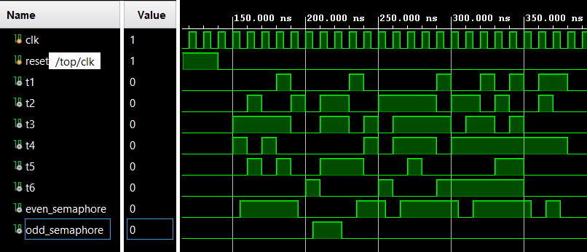
Figure 5. Waveforms from DUT for random train requests

Digital Circuit Verification
Verification Environment Architecture
Verification Checklist
Functional Coverage Elements
Verification Scenarios
Tests Results

Verification Environment Architecture
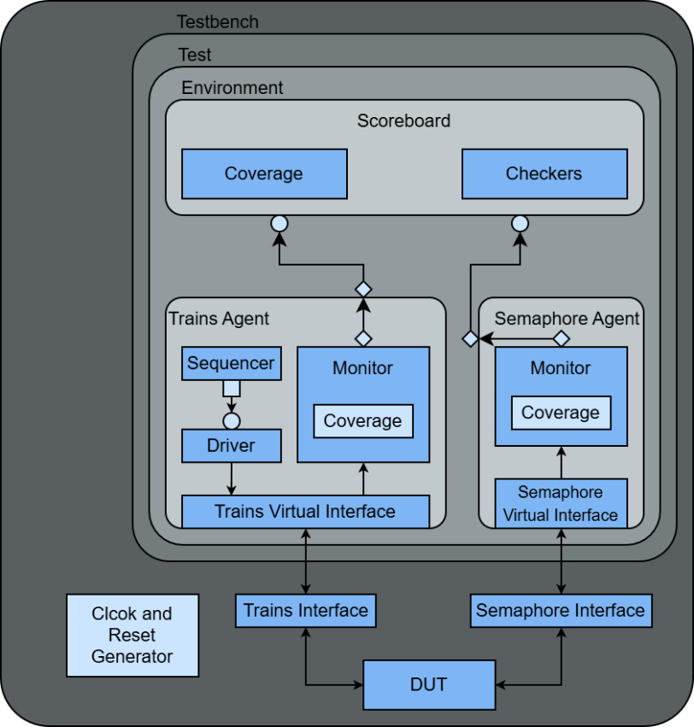
Figure 6. Overview of the components necessary for sending stimuli to the DUT

Trains Agent
The Trains Agent is an active agent that encapsulates the Sequencer, Driver and Monitor into a single entity, connecting the components with the DUT using the virtual interface.

Trains Transaction
Table 4. Trains Transaction
Field Name | Type | Size | Values | Description
t1_i | rand bit | 1 | [0:1] | Access request for T1
t2_i | rand bit | 1 | [0:1] | Access request for T2
t3_i | rand bit | 1 | [0:1] | Access request for T3
t4_i | rand bit | 1 | [0:1] | Access request for T4
t5_i | rand bit | 1 | [0:1] | Access request for T5
t6_i | rand bit | 1 | [0:1] | Access request for T6

Trains Driver
The Trains Driver interacts with the DUT via the Trains Interface, sending the transactions generated by the Trains Sequencer.
The driver receives transactions from the sequencer and drives the trains requests signals.

Trains Monitor
The Trains Monitor samples the request signals of the trains from Train Virtual Interface every clock cycle, reconstructs the transaction and sends it to the Scoreboard and Train Coverage Collector.

Trains Coverage Collector
The Trains Coverage Collector is instantiated inside the Trains Monitor and receives transactions from it. The coverage collector contains one coverpoint for each train request: t1, t2, t3, t4, t5, t6; and requests_cross.

Trains Sequences
The Trains Sequences generate stimulus for the Trains Driver. Each sequence creates one or more constrained-random transactions that the driver sends to Trains Interface. The following sequences are implemented:

Table 5. Trains Sequences
Sequence | Description
single_train_request  _sequence | Sends requests from each train individually.
odd_even_priority  _sequence | Sends simultaneous requests from one odd-numbered train and one even-numbered train.
same_parity_priority  _sequence | Sends simultaneous requests from two trains belonging to the same parity group.
same_train_repeated  _sequence | Sends repeated requests from the same train in two consecutive cycles.
all_requests_sequence | Sends requests from all trains simultaneously.
stress_sequence | Sends train requests at a higher rate than normal operating conditions.
trains_sequence | Sends random combinations of train requests.

Semaphore Agent
The Semaphore Agent is a passive agent that contains only the Monitor and connects it with the DUT using the virtual interface. The Semaphore Interface has only output signals from DUT, meaning no driver or sequencer is needed.

Semaphore Transaction
Table 6. Semaphore Transaction
Field Name | Type | Size | Values | Description
even_semaphore  _state | rand bit | 1 | [0:1] | State of semaphore for even numbered trains
odd_semaphore  _state | rand bit | 1 | [0:1] | State of semaphore for odd numbered trains
winner_train | rand train_state_t | 3 | {NO_TRAIN, TRAIN1, TRAIN2, TRAIN3, TRAIN4, TRAIN5, TRAIN6} | Train that has access to the railway

Semaphore Monitor
The Semaphore Monitor samples the semaphore states and the chosen train every clock cycle, reconstructs the transaction and sends it to the Scoreboard and Semaphore Coverage Collector.

Semaphore Coverage Collector
The Semaphore Coverage Collector is instantiated inside the Semaphore Monitor and receives transactions from it. The coverage collector contains 3 cover points: even_semaphore_state_cp, odd_semaphore_state_cp and winner_train_cp.

Scoreboard
The Scoreboard receives transactions from both monitors.
When receiving a Trains Transaction, the scoreboard predicts the next train that will enter the railway and the next activated semaphore, meaning the next Semaphore Transaction.
All predicted Semaphore Transactions are stored in a queue.
When receiving a Semaphore Transaction, the scoreboard compares it with the predicted transaction, generating an error message if the checker fails.

Scoreboard Coverage Collector
The Scoreboard Coverage Collector is instantiated inside the Scoreboard and receives transactions from it. The coverage collector contains 2 coverpoints: current_state and next_state; and transitions cross.

Functional Coverage Elements
Table 8. Trains cover group
trains_requests_cg
Cover point | Values | Description
t1 | [0:1] | Covers request of T1
t2 | [0:1] | Covers request of T2
t3 | [0:1] | Covers request of T3
t4 | [0:1] | Covers request of T4
t5 | [0:1] | Covers request of T5
t6 | [0:1] | Covers request of T6
requests_cross | t1 x t2 x t3 x t4 x t5 x t6 | Covers all combinations of requests

Table 9. Semaphore cover group
semaphore_states_cg
Cover point | Values | Description
even_semaphore_state_cp | {GREEN, RED} | Covers states of semaphore for even_numbered trains
odd_semaphore_  state_cp | {GREEN, RED} | Covers states of semaphore for odd_numbered trains
winner_train_cp | {NO_TRAIN, TRAIN1, TRAIN2, TRAIN3, TRAIN4, TRAIN5, TRAIN6} | Covers the trains that have access to the railway

Table 10. Scoreboard cover group
fsm_cg
Cover point | Values | Description
current_state | {NO_TRAIN, TRAIN1, TRAIN2, TRAIN3, TRAIN4, TRAIN5, TRAIN6} | Covers current state of the railway
next_state | {NO_TRAIN, TRAIN1, TRAIN2, TRAIN3, TRAIN4, TRAIN5, TRAIN6} | Covers next predicted state of the railway
state_transition | current_state x next_state | Covers the valid transitions between railway states

Verification Scenarios and Tests
Table 11. Verification Scenarios
Scenario | Description
Single Train Request Verification | Individual train requests are applied to verify correct semaphore activation and train selection.
Odd-Even Priority Verification | Simultaneous requests from odd-numbered and even-numbered trains are applied to verify the priority rules.
Same Parity Priority Verification | Simultaneous requests from trains belonging to the same parity group are applied to verify the internal priority hierarchy.
All Requests Verification | Requests from all trains are asserted simultaneously to verify the complete arbitration mechanism.
Repeated Train Request Verification | Consecutive requests from the same train are applied to verify that the train cannot be selected in consecutive arbitration cycles.
Idle Cycle Verification | Request sequences are applied to verify insertion of the idle state when switching between odd and even train groups.
Stress Traffic Verification | Frequent train requests are generated to evaluate DUT behavior under heavy traffic conditions.

Table 12. List of implemented tests for DUT verification
Test file name | Test description
single_train_request  _test | Test that DUT grants access correctly when requests are generated by a single train.
odd_even_priority  _test | Test that DUT prioritizes odd-numbered trains over even-numbered trains.
same_parity_priority  _test | Test that DUT applies the correct priority order between trains of the same parity.
same_train_repeated  _test | Test that DUT does not grant access to the same train in consecutive arbitration cycles.
all_requests_test | Test that DUT applies the complete priority hierarchy when all trains request access simultaneously.
stress_test | Test that DUT operates correctly under heavy traffic conditions with frequent train requests.
trains_test | Test that DUT handles random train requests correctly.

Results
Running the regression produced the following results:
- Trains functional coverage: 100%
- Semaphore functional coverage: 100%
- Scoreboard coverage: 100%
Semaphore assertions passed without failures throughout the simulation

